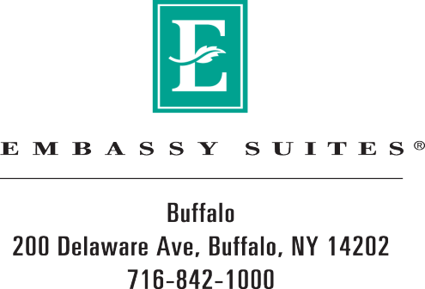
The Embassy Suites by Hilton Buffalo offers a variety of affordable packages designed to meet the specific needs of meeting and event planners, from social to corporate functions.

